Title | Mapper Software Subsystem Requirements Specification
Distribution | Software Archive
Author | Jax Yang |  | Date | 2014-1-06
Review | See review section |  | Date | See review section
Approved |  |  | Date
Approved |  |  | Date
Remarks | All Requirements will be implemented as defined in this document and tested accordingly.
Contents

1 Introduction 3
1.1 Scope 3
1.2 Definitions, acronyms, and abbreviations 4
1.3 Document conventions 5
2 Overall description 5
3 Assumptions and dependencies 6
3.1 Assumptions 6
3.2 Dependencies 7
4 Constrain 7
4.1 ABB Framework 7
5 Non-functional requirement 7
5.1 Optimization Requirement 7
5.2 Module Test Requirement 7
5.3 Code Static check Requirement 7
6 Functional requirements 8
6.1 PV/SV/TV/QV Mapping 8
6.2 PV/SV/TV/QV supports HART spec 9
6.3 Current out source 9
6.4 Digital out source 9
6.5 Diagnosis support 10
6.6 Manage 4 device variables 10
6.7 Map list management 11
6.8 Manage the flow over 103% alarm behaviour 11
6.9 External Temperature unit 11
6.10 Pressure unit 11
6.11 Density unit 12
7 Safety Requirements 12
Safety Requirements 12
8 Subsystem Documentation 12
9 References 12
10 Revision History 12
11 Requirement Review 13
11.1 Decision of the Review: 13
11.2 Check list: 13
11.3 Remarks: 13
11.4 Defects 13
11.5 Changes are proved: 15

List of Figures
Figure 1: CB software architecture 3
Figure 2: Mapper Subsystem Use Case Diagram 6

List of Tables
Table 1: PV SV TV QV management 8

Introduction

Scope
This document is intended to specify the software requirements for the Mapper Subsystem. The Mapper Subsystem is part of the VT5 software.
Mapper is designed as bridges, which mainly connect HART subsystem and diagnosis subsystem, HART subsystem and HMI subsystem, HMI subsystem and diagnosis subsystem, HART/HMI subsystem and other subsystems which mange the device variable of the device.

The CB software architecture is showed as Figure 1.

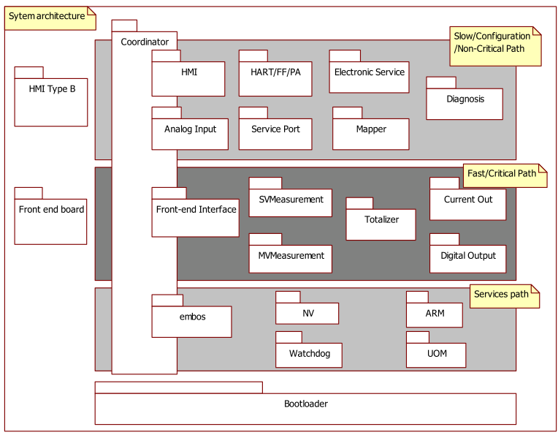
Figure 1: CB software architecture

Definitions, acronyms, and abbreviations
Term | Definition
HMIGen | A software tool used to generate the HMI subsystem common source code.
EntryTool | A software tool used to generate the subsystem framework source code.
HART | 2 Wire communication protocol (Highway Addressable Remote Transducer)
Current Out | A subsystem used to output 4~20 mA to send measure result and alarm information if any alarm occurred.
Digital Out | Subsystem used to output digital signal to send measure result and alarm information if any alarm occurred.
HMI | Human Machine Interface for local user access via display and key input.
Diagnostic subsystem | A subsystem responsible for handling error conditions and warnings. Also provides General Alarm data for the Digital Output subsystem
NV subsystem | A subsystem responsible for read / write access and maintenance of non-  volatile memories (in transmitter and sensor).
Qv | Volume flow
Qn | Volume flow under standard condition
Qm | Mass flow
Qp | Energy flow
QvPartial | Partial volume flow
QnParial | Partial volume flow under standard condition
MVM subsystem | Multi-Variable Measurement, mainly mange the Qn,Qm,Qp, QvPartial,QnPartial,
SVM subsystem | Single Variable Measure subsystem used to manage the Qv.
UOM subsystem | Subsystem used to converting units
Electronic Service subsystem | Subsystem used to manage the electronic parts, such as ROM/RAM checking ,board temperature, dip switch etc.
ServicePort subsystem | Subsystem providing communication like HMI & HART for service engineer on HMI connector.
TOT | Subsystem used to totalize the device variable Qv,Qn,Qm,Qp,QvPartial,QnPartial.
Classification | The device variable type from the point of view of HART protocol
Operating Mode | The device work mode
PV | Primary variable define by HART protocol used to dynamic mapping real device variable
SV | Secondary variable define by HART protocol used to dynamic mapping real device variable
TV | Tertiary variable define by HART protocol used to dynamic mapping real device variable
QV | Quaternary variable define by HART protocol used to dynamic mapping real device variable
CO | Current out subsystem
DO | Digital out subsystem

Document conventions
Software requirements are identified using the following in-line table format:
Ident. | Definition / Motivation | Priority | Source
 |  | Stability | Source
Each field is described in the following list:

Ident. a unique identifier for the Requirement
Priority one of: Mandatory / Desirable / Future
Stability one of: Committed (Agreed by approvers) / Not yet agreed / Likely to change

Overall description

Mapper subsystem is the bridge to connect different subsystems. Take HART reading diagnosis action for example, HART subsystem get the diagnosis information from Mapper, then Mapper will get the current diagnosis information from Diagnosis subsystem. It means that HART won’t access the diagnosis subsystem directly.

Mapper aims to manage diagnosis information mapping, 4 device variables (external temperature, pressure, density, and content), HART PV/SV/TV/QV mapping, and device variable mapping. The use case of Mapper is described as Figure 2.
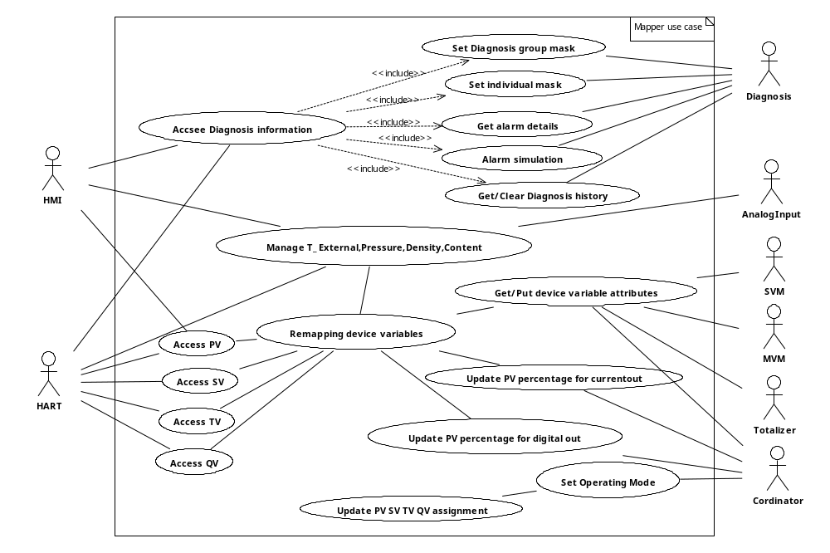
Figure 2: Mapper Subsystem Use Case Diagram

Assumptions and dependencies

Assumptions

- When there is any error status, mapper just passes it through to the calling subsystem. When it’s possible, mapper will return error code defined in the framework. So the user or mapper, for example, HART, should convert those error statuses into its specific error code.

Dependencies

- Development and testing will be done regarding to the following conditions:

  - Compiler: IAR compiler v3.4
  - Framework: 2.3.1
  - Oscillator frequency: 3.686 MHz
  - CPU clock: 1.843MHz
  - System update rate / execution time:

Constrain

The following requirements are related to the fact that Mapper shall base on, or the features should be developed in the subsystems.

ABB Framework
Ident. | Definition / Motivation | Priority  M | Source  R&D
Mapper 4.1 | ABB Framework  Mapper subsystem shall base on ABB framework. | Stability  C | Source  R&D

Non-functional requirement

Optimization Requirement
Ident. | Definition / Motivation | Priority  M | Source  R&D
Mapper 5.2 | Optimization  No compiler optimizations are permitted | Stability  C | Source  R&D

Module Test Requirement
Ident. | Definition / Motivation | Priority  M | Source  R&D
Mapper 5.3 | Module test  Mapper subsystem shall have module test | Stability  C | Source  R&D

Code Static check Requirement
Ident. | Definition / Motivation | Priority  M | Source  R&D
Mapper 5.4 | Code Static check  Mapper subsystem shall pass pc-lint test, do the static code test | Stability  C | Source  R&D

Functional requirements

PV/SV/TV/QV Mapping
Ident. | Definition / Motivation | Priority  M | Source  R&D
Mapper 6.1 | PV/SV/TV/QV Mapping  - For each measurement selection, Mapper shall map device variables to PV/SV/TV/QV as Table 1.  - When user selects the temperature as current out-source, PV and SV shall be exchanged. That means PV assigned to “Flow” and SV assigned to “Temperature” | Stability  C | Source  R&D

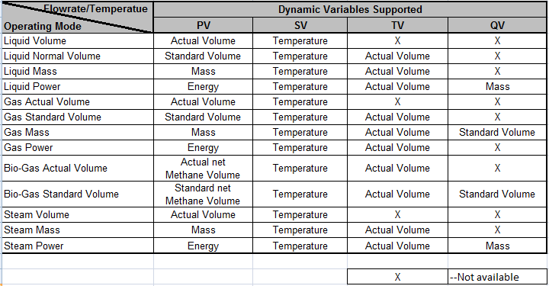

Notes:
Case 1: Once the user selects Flow as current output, then the PV, SV, TV, QV will be set as above.
Case 2: Once the user selects Temperature as current output, then the PV and SV are exchanged in case 1, TV and QV keep the same as in case 1.
Table 1: PV SV TV QV management

PV/SV/TV/QV supports HART spec
Ident. | Definition / Motivation | Priority  M | Source  R&D
Mapper 6.2 | PV/SV/TV/QV supports HART spec  - For each measurement selection, Mapper shall decide which device variable to be supported.  - For getting information of PV/SV/TV/QV, Mapper shall return the device variable actual information HART intend to access when the device variable is supported. The mapping information include:  - Value damped  - Unit code  - Unit type  - Classification  - Status  - Damping time  - Upper range  - Lower range  - Percentage  - Range span  - Limit high range  - Limit low range  - Value before damping  - Changing information of PV/SV/TV/QV, Mapper shall change the actual information to the device variable when this device variable is supported. The information include:  - Unit  - Upper range  - Lower range  - When HART accessing PV/SV/TV/QV, Mapper shall return value and error code if current operating mode doesn’t support the device variable. | Stability  C | Source  R&D

Current out source
Ident. | Definition / Motivation | Priority  M | Source  R&D
Mapper 6.3 | Current out source  Mapper shall provide an interface to get PV percentage | Stability  C | Source  R&D

Digital out source
Ident. | Definition / Motivation | Priority  M | Source  R&D
Mapper 6.4 | Digital out source  Mapper shall provide an interface to get flow percentage as defined in Table 1 case. | Stability  C | Source  R&D

Diagnosis support
Ident. | Definition / Motivation | Priority  D | Source  R&D
Mapper 6.5 | Mapper shall provide these functions as below:  - Read alarm history  - Clear alarm history  - Mask group alarm as below:  - Maintenance Required  - Function Check  - Out Of Specification  - Mask Individual alarm as below:  - Min Flow rate alarm  - Max Flow rate alarm  - Flow > 103%  - Flow<Low flow cut off  - Temperature Sensor defect  - Sensor Temperature out of spec  - Simulate alarm as below:  - 0, simulate off  - 1, simulate current out  - 2,simulate digital out  - 4~6,8~9,11,14~17,20~24,27~30,35~51 simulate alarm inputs.  - Mapper shall provide interface to access diagnosis information as below  - Active alarm  - Alarm group according to Namur 107 | Stability  N | Source  R&D

Manage 4 device variables
Ident. | Definition / Motivation | Priority  D | Source  [RS004] 4.13.3
Mapper 6.6 | - Provide interface to these 4 device variables:  - External temperature,  - Pressure (abs)  - Density  - Content.  - These variables shall have 3 input channels:  - Analog Input  - HART input  - Preset  - These variables can be simulated  - The range of these variables shall be configurable, the default range shall be as below:  - External temperature:-200~500 degree C.  - Pressure (abs): 0~40101.325 kPa  - Density: 0.08~ 3000.0 kg/m3  - Content: 0~100%  - Detect pressure alarm | Stability  N | Source  [RS004] 4.13.3

Map list management
Ident. | Definition / Motivation | Priority  D | Source  R&D
Mapper 6.7 | Mapper shall provide the common interface for variable management. | Stability  N | Source  R&D

Manage the flow over 103% alarm behaviour
Ident. | Definition / Motivation | Priority  D | Source  R&D
Mapper 6.8 | Manage the flow over 103% alarm behaviour, there are 3 options when the current flow exceed 103% of upper range of measurement:  - OFF, which means no alarm current will be output when there is a flow over 103% alarm occurred.  - Output low alarm current when there is a flow over 103% alarm occurred.  - Output high alarm current when there is a flow over 103% alarm occurred. | Stability  N | Source  R&D

External Temperature unit

Ident. | Definition / Motivation | Priority  M | Source  [RS004] 4.7
Mapper 6.9 | Units of temperature:  1) User shall be able to change the temperature unit as one of the Degrees Celsius, Degrees Fahrenheit, Kelvin unit via HART or HMI.  2) Base unit is Degrees Celsius | Stability  C | Source  [RS004] 4.7

Pressure unit

Ident. | Definition / Motivation | Priority  M | Source  [RS004] 4.8
Mapper 6.10 | Units of pressure:  - User shall be able to change the pressure unit as one of the Pa,MPa,KPa,HPa,bar,mbar, psi, or kg/cm2unit via HART or HMI  2) Base unit is kPa. | Stability  C | Source  [RS004] 4.8

Density unit

Ident. | Definition / Motivation | Priority  M | Source  [RS004] 4.9
Mapper 6.11 | Units of density:  1)User shall be able to change the density unit as one of following unit via HART or HMI.  Units of density:  gr/cm3,gr/dm3,kg/dm3,kg/m3,t/m3,lb/ft3,lb/in3,lb/UKgal, lb/Usgal  2)Base Unit is kg/m3 | Stability  C | Source  [RS004] 4.9

Safety Requirements

Ident. | Definition / Motivation | Priority  D | Source  R&D
Mapper 7.1 | Safety Requirements  - Mapper is in the safety loop [2].  - Mapper shall protect PV assignment. | Stability  N | Source  R&D

Subsystem Documentation

The following documents have to be generated for the Subsystem:

- Software Design Description including performance data
- Test Plan
- Code review

References
Ref. | Document
[1] | RS004-VT5 Software Requirement Specification
[2] | DS002-VT5 FW Design Specification

Revision History
Rev. | Description of Version/Changes | Primary Author(s) | Date
0.1 | Initial revision. | Jax Yang | 2013-4-16
0.2 | Modified this document according to the review result of Initial revision. | Jax Yang | 2013-4-27
0.3 | Add Mapper 6.9~6.11 | Jax Yang | 2013-5-26
0.4 | Update the flow over 103% alarm behaviour in section 6.8 | Jax Yang | 2014-01-06

Requirement Review
Dept. | Name
R&D ShangHai | Merrick Huang, Lawrence Shi, Zuochen Wang, Spring Zhou, Tongkun Liu, Vincent Liu | 2013-04-27 rev0.2

Dept. | Name
R&D ShangHai | Zuochen Wang, Spring Zhou | 2013-05-26 rev0.3

Dept. | Name
R&D ShangHai | Merrick Huang | 2014-01-06 rev0.4

Decision of the Review:
 | Decision | next steps
 | Inspection passed without restrictions | Phase finished
X | Inspection passed with restrictions | some changes must be done
 | Inspection not passed | Inspection must be repeated

Check list:
 |  | yes | no | N.A.
1. | Does the specification explain the currently known requirements that the product finally has to perform? | Y
2. | Are complex subjects explained? | Y
3. | Are all used abbreviations and technical expressions explained? | Y
4. | Are all referenced documents in the reference list? | Y
5. | Contains the document a rough overview of the product’s main functionality? | Y
6. | Are all requirements referenced? | Y
7. | Are all requirements testable? | Y
8. | Is the typical environment of the product described? | Y
9. | Is defined which components already exist, will be bought or self-written? | Y
10. | Are safety requirements (e.g error-detection, error-handling) specified? | Y
11. | Are service/update requirements described? | Y
12. | Are all dependencies to other requirement documents considered? | Y
13. | Are templates used in a correct manner? | Y
14. | Are all open issues transferred to the defects table? | Y

Remarks:

Defects
No. | Checkpoint | Description | Major Defect | done  Date
1 | 13 | Change the use case diagram:  - Get PV percentage for current out -> Update PV percentage for current out  - Get PV percentage for digital out -> Update PV percentage for digital out | N | 2013-4-27
2 | 8 | The revision of Framework should be 2.3.1 | N | 2013-4-27
3 |  | Replace the statement “should” with “shall” in section 6.1 | N | 2013-4-27
3 | 7 | Mapper 6.2 part 4:  Specify the error code supported. | Y | 2013-4-27
4 | 9 | Mapper 6.3 shall be described clearly, and don’t need part 2 and part 3 need to be deleted, because it has been specified in table 1.  Mapper 6.4 has the same problem. | Y | 2013-4-27
5 | 7 | Mapper 6.5 shall describ the functions in details.  Part1:  - Mapper shall provide the functions but not information.  - alarm history shall be specified the operations:read/clear  - specify the group mask cases.  - specify the Individual mask cases.  - Specify the alarm simulation in details  Part2:  - Mapper shall provide interface but not information  - The information accessed by the interface shall be:  - Active alarm  - Alarm group according to Namur 107 | Y | 2013-4-27
6 | 7 | Mapper 6.6  - “Diagnosis support” need to be deleted  Part 1:  - “Manage 4 device variables” shall be modified as “Provide interface to these 4 device variables”  - “may” shall be modified as “shall”  - “HART” shall be modified as “HART input”  - “HMI preset” is wrong, shall be modified as “preset”  Part 3: need to be delated  Part 4: don’t need to specify how to simulate the variables.  Part 5: The Density range shall be 0.08~3000 kg/m3 | Y | 2013-4-27
6 | 6 | The pressure alarm detection need to be added. | Y | 2013-4-27
7 |  | Table 2 need to be deleted. | N | 2013-4-27
8 |  | Some spell errors.  “aim” shall be “aims” , and “variable” shall be “variables” in section 2 | N | 2013-4-27
9 |  | Test report shall be deleted | N | 2013-4-27
10 |  | Add Mapper 6.9~6.11 according to new architecture | N | 2013-5-26
11 |  | Modify the section 6.8 about the flow over 103% alarm behaviour according to market requirement | N | 2014-1-06
12 |  | Modify the reference documents name | N | 2014-1-06

Changes are proved:
The Reviewer confirms that all changes are done:
Proved Rev: | Date: | Reviewer:
0.3 | 2013-05-27 | Spring Zhou, Zuochen Wang
0.4 | 2014-01-06 | Merrick Huang

